The MITCHAM HISTORIcal society
IncORPORATED NEWSLETTER

POSTAL ADDRESS: PO Box 903 Mitcham Shopping Centre S. A. 5062

Web Site: http://www.mitchamhistoricalsociety.org.au/bgHistory.htm

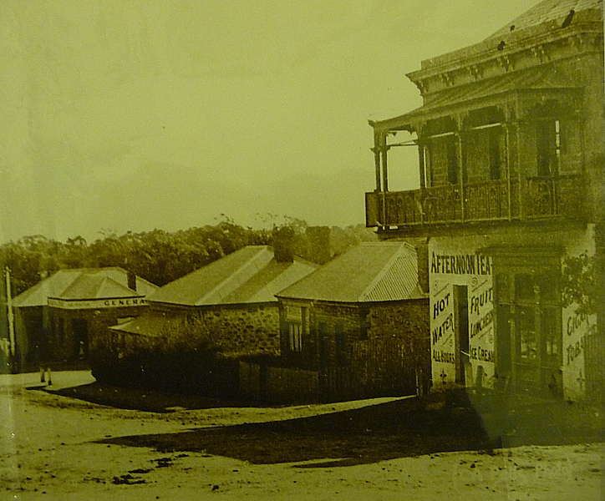
Mitcham Memories

Volume 5 Number 1 March 2012

Title & Index page | 1 |  | Editorial, Disclaimer, Privacy Act. | 2
Message from Chairperson | 3 |  | Program for 2012 | 4
Twilight walk Flier | 5 |  | Battunga Country Flier | 6
Allison’s Apothecary Flier | 7 |  | Strathspey Flier | 8
Samuel Tapscott and Stoneybank Farm | 9 |  | Restoration at last! | 19
Duck Canning Factory | 23 |  | Address Page | 24

OFFICE BEARERS FOR 2011

Patron: | Mr Tim Oughton | Principal Scotch College
Chairperson | Julie Hogan | Tel: 0430472262 or 8338 3238
Vice Chairperson & Editor | Rick Irving | Tel: 08 8272 9707
Treasurer | Brian Angus
Secretary | Cheryl Schneider
Committee Members | Trish Cosh | Margaret White  K
 | John Wood | Christine Edwards
 | Rowena Atkinson

EDITORIAL

Researching our Newsletter is far from being a dull or uninteresting pastime; rather it is both interesting and exciting. This edition is no different from any other; I have really enjoyed researching the stories. I often find that the more I research, the more I have unanswered questions that I need answers for to properly write the story.

Every year brings new knowledge, and this year of 2012 is no exception. I have learned a lot of interesting things, which I really want to share, hence this newsletter. Naturally, our emphasis is on the past, both in Mitcham and other parts of South Australia, but some of the stories continue into the present time.

Perhaps it is significant that some of these stories do continue into the present time, for by doing so, their historical information remains in our minds. After all, our history is the key to our future.

DISCLAIMER

Views and opinions expressed in articles in the Newsletter do not necessarily reflect the views of the Mitcham Historical Society Inc. While every effort is made to ensure the accuracy of articles printed, responsibility is not accepted for any errors they may contain that are out of the Society’s control.

THE PRIVACY ACT

A member’s personal information collected by the Society, for example name, address and telephone number, will only be used for forwarding of the Newsletter and relevant information concerning the Society. The information will not be shared, sold or given to any third party without the member’s consent. Any e-mails will be treated as above. However, any information sent by e-mail will be at the sender’s risk and the Society will not be held responsible for any unintended use or disclosure of this.
MESSAGE FROM CHAIRPERSON

Picture: September 2011 AGM - Life Membership Presentation
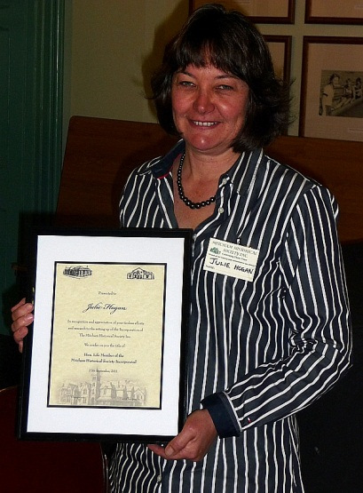
Welcome back everyone from the Christmas Break!

I hope that everyone is having an enjoyable summer, although the weather has been a bit “undecided”. Today as I’m writing this, the expected high is about 23 degrees and this is in February (usually our hottest month). At least those of us with air conditioners can save on electricity.

For me, January started with medical emergencies with my husband Colin and son Andrew both requiring ambulances to hospitals. Colin fell from a rock while fishing in Kangaroo Island and luckily he escaped with a couple of broken ribs and crushed discs, and had no internal injuries. Sadly he didn’t catch any fish but we got to spend New Year’s Eve with the friendly ambulance driver and his wife. My son Andrew had an anaphylaxis episode and was rushed to the Royal Adelaide. The hospital was full of police as Vincenzo Focarelli was also there, as well as a bomb scare in the main foyer. I spent the night in the hospital with Andrew, who recovered well. It appears he was having a reaction to the acne medication that he was taking. I am certainly glad that I have kept up the ambulance cover and advise people to do the same as you just don’t know what is round the corner. Speaking of what’s round the corner, we have put together a variety of events for our Programme 2012 so check these out.

First up is our Twilight Walk on the Monday evening of the 5th of March, so don’t miss this opportunity to take a stroll round the Mitcham Village neighbourhood. The illustrious, informative Glen Woodwood will be our guide (and if we are lucky, he might even lead us up the occasional garden path). In April we have our Autumn bus trip, this time to the Battunga Region, which encompasses areas such as Echunga, Meadows and Macclesfield. I hope that our members can find an event of interest in our programme to attend.
A thought to consider:
“Not the power to conquer others, but the power to become one with others, is the ultimate power”. Sri Chinmoy

PROGRAMME FOR 2012

March
Monday 5th: 6pm to 8pm
Twilight Walking Tour – Mitcham Village
Hosted by Glen Woodward
Meet at Mitcham Heritage Research Centre
Cost: Gold coin
Contact: Julie Hogan: 8338 3238 or 0430 472 262

April
Mines/Wines & Markets Bus Trip
Sunday 22nd Time: 9.30am
Visiting Macclesfield, Meadows & Prospect Hill
Bus departs from Mitcham Council Car Park
Cost to be advised
Limited seats so book early to avoid disappointment
Contact: John Wood: 8373 3374 or 0402 781 601
Julie Hogan: 8338 3238 or 0430 472 262

May
About Time S. A.’s History Festival Activities

Strathspey Tour – Mercedes College
Sunday 6th May Time: 2pm
Tour of Historical Strathspey Building
Contact: Julie Hogan: 8338 3238 or 0430 472 262

Allison’s Apothecary Opening
21 Albert Street, Mitcham Village
Wednesdays 9th, 16th & 23rd May
Contact: Trish Cosh: 0418 829 034

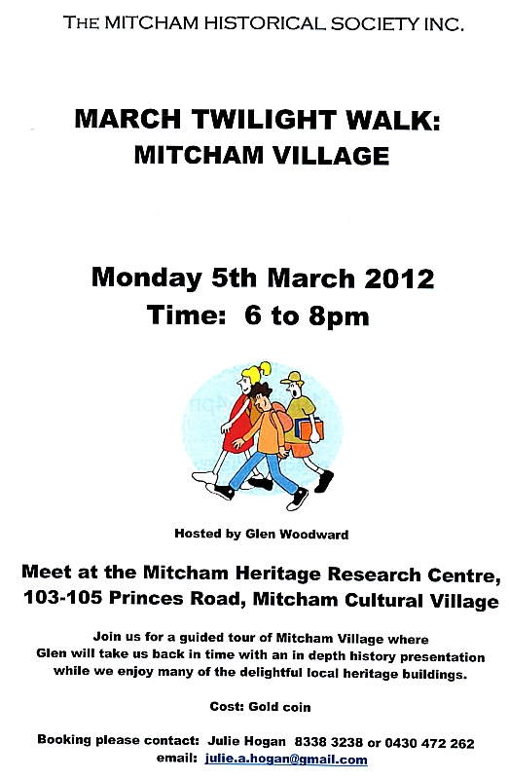
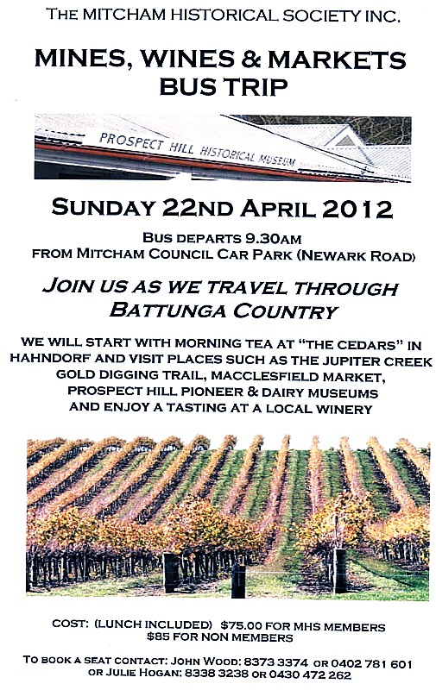

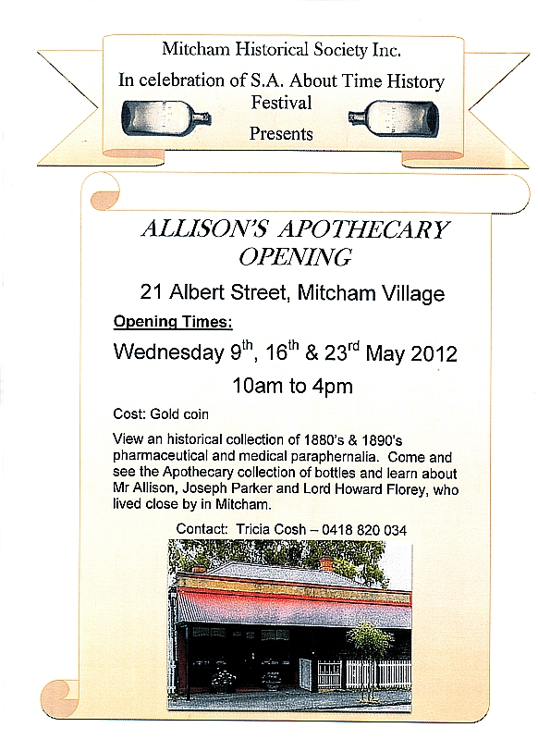
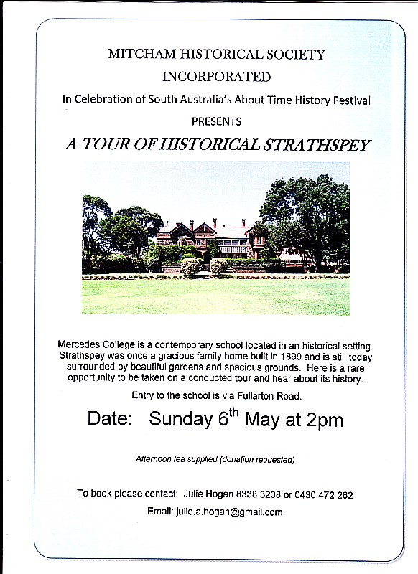
Samuel Tapscott and Stoneybank Farm

Samuel Tapscott was born in High Ham, Somerset in 1825 , the son of Robert Tapscott and Elizabeth Holway, and, as shown High Ham Parish Register, was baptized in the Parish Church on 2 April 1825 He is mentioned in the 1841 census as a boy, aged 16. Eight years later, as a shepherd, he immigrated to Adelaide on the "Sir Edward Parry", which departed from Plymouth, Devon, England, on 20 March 1849 He arrived in Adelaide on Thursday, June 21st 1849.

Samuel found employment from amongst the abundant number of sheep farms in the Mt Pleasant district and married Harriet Phillis, a daughter of doughty agriculturalist James Phillis Senior. Samuel and Harriet were married on the 6th of November 1854, by the Rev. W. H. Coombes, at St. George’s (Anglican) Church, Gawler.

But why were they married in Gawler? Paula Bartsch points out that “The churches in Mount Pleasant were not built until the 1860s, and the ministry was not resident in the area before then, so that would account for the marriage at Gawler.” Personal Internet searches have revealed that St. George’s Church was built in 1848, far earlier than other local churches.

Soon after their marriage, the young Tapscott’s settled on Stoneybank, a dairy farm which James passed on to his daughter. We are indebted to a Special Reporter from The Observer, who wrote a lengthy article entitled “A VISIT TO THE DAIRYING DISTRICT “after visiting the Tapscott’s in 1882, for an excellent description of their property. He writes “His farm consists of about 800 acres of well-grassed but very stony land, of a hilly character, with some immense boulders of granite, and most romantic scenery. There are a great many springs upon the property and the water as a rule is of first-class quality. There are a few sheaoaks growing on the hills, but in the flats there are numbers of greygums that have been dead for years and years, their white bleached trunks and long arms standing out like the ghosts of a departed forest. From the top of the hills a most extended view is gained to the eastward over the Reedy Creek Special Survey of 20,000 acres of similar character and further over is seen the Murray River, with mile upon mile of farms, extending from north to south, bounded by the scrub, through which the Murray River winds its course. The river is fourteen miles distant from Mullundella Creek, and can be plainly discerned, looking like a silver streak amidst the sombre mallee scrub. The township of Palmer is not very far distant from the boundary of the farm – about six miles – and to this place the children have to walk every day for their schooling – a feat which may well be described as the pursuit of knowledge under difficulties.

The dwelling-house is built in a sheltered place, with a steep hill at the back, and a spring running in front. There is a nice little kitchen garden attached, and an orchard with from 100 to 150 trees in it. There was more to the Tapscott’s farm than as described above, of which there will be further description in another part of this article.

How can we, describe Samuel Tapscott in such a way as to painting a living picture? Just what sort of man was he? The reporter from “The Observer” gives us this information – “He proved to be a bluff hearty farmer, possessing a large amount of information upon many subjects and endowed with a perennial stream of conversation of a most entertaining character.” To this word-picture, I would also add to this description that he was a person possessed of a wide range of agricultural interests, willing to diversify on his farm. Apart from being a well known and hard working dairyman and cheese maker in the community, he also included sheep and pigs on the farm, grew tomatoes, figs, currants and apples, all of which he exhibited at local and other agricultural shows.

At a ploughing Match at Mount Pleasant, on the 18th of September, 1856, the South Australian Register for Saturday 27th of September 1856, on page three that “In order to provide accommodation for the guests at the dinner, the landlord of the Mount Pleasant Inn had erected a temporary pavilion 40 feet in length, beneath the balcony of the inn. About 50 gentlemen sat down to the festive board, the contents of which were both excellent and ample, reflecting great credit on mine host McBeath.,” at which “Mr. Samuel Tapscott proposed The Health’s of the Visitors. He hoped next year their number would be doubled and trebled. Mr. Tapscott (also) proposed The Health’s of Lady MacDonnell and the Ladies of South Australia.”

As noted above, Samuel not only made cheese, but also won prizes at shows with it, notably in the years before 1882. In that year, a Mr. Crawford, made remarks on cheese-making at a meeting of the Agricultural Society (held on August 25, 1882) which did that class of industry a great injustice. Samuel, more than likely somewhat indignant, wrote to the Editor of the South Australian Register, as follows:-

“TO THE EDITOR
Sir— At a meeting of the Royal Agricultural Society, held - on August 25, Mr. W. Crawford in his remarks on cheese-making is doing that class of industry a great piece of injustice by saying that most of the cheese that comes into the market is made of skimmed milk. Now, I doubt whether Mr. W. Crawford would know skimmed-milk from new-milk cheese, or whether ever he has seen skimmed-milk cheese. I should judge, from Mr. Crawford's remarks at the meeting, that he has some shares in the cheese factories in the other colonies, or, like many more that I have heard speak at meetings, wishes to see his name in public print, for I am certain he knows nothing about cheesemaking. Mr. W. Crawford might be one of these skimmed-milk, cheese-price buyers, and wishes to get a good article for a low price. I have been a dairy farmer in South Australia for thirty years, and I have not seen skimmed-milk cheese yet and I have seen and made scores of tons, and am not tired of dairy-farming yet. I have never known a dairy farmer to go insolvent, although many a score of grocers have. Now, Sir, if Mr. Crawford will pay me a visit any time he likes I will show him a dairy farm for cheese and butter, and how to make it pay. In conclusion, I may mention I can sell a great deal more cheese than I can make at a paying price, and have it taken from the dairy house, cash being paid for the same,
I am, Sir, &c,
SAMUEL TAPSCOTT,
Dairy Farmer, Millendella, near Mount Pleasant.

His cheeses had won prizes at shows in 1867, 1868, 1877, 1878, and in other years. In fact, the reporter from The Observer notes “I have seen and tasted the cheeses as commonly made by Mr. Tapscott, and must say that they were equal in quality to New Zealand and Warrnambool cheese, for which high rates have been charged.” He advertised his prize-winning cheese in 1887, as shown below:-

“CHEESE AND BUTTER

The undersigned will be in Adelaide at the Plough and Harrow -with his SHOW CHEESE and BUTTER which took the FIRST PRIZE at the MOUNT PLEASANT SHOW. See the Judges' remarks in last week's daily papers. Letters will be acknowledged. SAMUEL TAPSCOTT, Mount Pleasant
Dated March 30, 1887”

Once again, thanks to the reporter from The Observer”, we have a very good description of both where and how his cheese was made. It states the following:-
“The dairy is an independent building, erected in a recess cut in the side of the steep hill at the back of the house, and has a narrow space all around it. The roof is double, the first being of galvanized iron, covered with thatch, but leaving a space between, the thatch being covered with earth and the whole shaded by a willow in summer. The door faces the south, and there is a ventilating aperture at each end. Through the middle of the floor a small spring tuns down a narrow channel, and beneath the doorsill during winter, but it is dry in summer; and other two channels run along each wall – both inside and out – to carry off any water that may enter from springs proceeding from the hill. The cows are now milked but once a day and the milk as soon as taken is strained, placed in large cans, with a handle on each side, and placed in a cauldron over a fire, in which the water is brought to nearly the boiling point – the proper heat is ascertained by experience and not by the use of a thermometer. It is then placed wither in the pans for skimming next day or emptied into a large vat made of tin, when the rennet is added, which in about twenty minutes turns it into curds and whey. When it is well turned the curd is first gently broken with a hand-dipper, and in time – about another twenty minutes – the largest portion of the whey has separated, and the curd is slightly salted, placed in a cheesecloth, and hung up on a hook till the afternoon to cool, and also to drain. It is then run through the curdmill, which reduces it to a mass which looks like a lot of chopped beef suet, and it is once again hung up to drain still further. Next morning the curd is ground for the last time, salted property, and put into the press, whence it is removed next day. The press is a compound lever, and will take in six cheeses if needed. When taken out it is wrapped with a clean cloth, which is renewed every day at first, and the cheese is turned; but as it gets riper the necessity for changing and turning is not so great. About six weeks is the shortest time allowed for ripening a cheese sufficiently to allow of its leaving the dairy, but six months is none too long. The earlier it is sold the heavier the cheese; but the maker who has a reputation to preserve takes care to preserve his cheeses also long enough to prevent its disgracing him. Butter is produced upon most, if not all of the dairy farms, and although skim-milk cheeses are not made I believe that skim-milk form a more or less a constituent part of much of the cheese that is made. This is a practice common to cheesemakers all over the work, but with some makers the desire to make as much butter as possible induces them to take even more than half the cream away, and the result is a miserable dry product that is neither chalk nor cheese.”

Apart from dairy cattle, in 1882 we are told that Samuel kept a good many pigs and fowls, which he says must form part of the dairy to make it pay, and prevent waste. His sheep number only about 400, and these he culls every year in order to keep his wool of an even quality. His sheep are very good, and his wool brings highest price; 5 bales grown by Mr. S. Tapscott, sold at 8½d per pound in 1888, the next year 5 bales were sold for 9¾d per pound.

“The remembrance of last year's disastrous fire has made the farmers particularly anxious to get their wheat stacked; they have been more cautious this year in preparing against fire.” Living at Stoneybank, Samuel would certainly been well aware of the dangers of fires, as the above excerpt refers to. The fire in question was indeed devastating. “On Wednesday, the 11th instant, a fearful fire ravaged the country round Mount Pleasant, consuming feed and cornstacks in every direction. Great efforts were made to confine the fire within the narrowest possible bounds, but it desolated, nevertheless, a great extent of country.” On Wednesday, the 28th February, a bush fire broke out on the Reedy Creek Special Survey, but was put out before it did much damage. The Hon. John Baker and Mr. Samuel Tapscott have lost some grass by it. The dairy-farmers have in the past depended almost entirely upon the natural herbage, and this has more than once or twice been destroyed by fire, when they have been put to great straits with their cattle. There is a report from when Samuel’s son Vincent ran the farm, stating that: “Mr. V. R. Tapscott's mixed farm at Stonybank, about five miles east of Mount Pleasant, has been in the possession of the family for 70 years, and during that time has experienced 17 bush fires, and has been practically burnt out 13 times. The fire which occurred three weeks ago cleared the farm, but Sunday's blaze seemed to burn right over the bare ground. He also lost a number of sheep.”

Samuel and Harriet Tapscott had their first son on the 27th of May 1855, soon after arriving in Mount Pleasant. They were to have a family of fourteen, eight sons and six daughters. On his visit to the Tapscott farm in 1882, the reporter from The Observer, said in regard to the Tapscott family, the following – “Mr Tapscott is the happy father of fourteen children, thirteen of whom are alive and several have been started upon farms on their own account. The whole of this large family have been reared and placed out by the aid of dairy farming, and he says that he cannot but speak in the highest terms of the industry that has enabled him to achieve so satisfactory a result.” In between looking after her family of six daughters and eight sons, Harriet tended camellias which acted as sentinels on each side of French windows at the homestead, reminiscent of her Kent childhood home. Eventually, someone had to cut holes in the verandah for the bushes to grow through and over the roof—understandably, the flowering seasons brought forth a spectacular sight.

When the reporter referred to in the above paragraph visited the farm, Samuel was approaching sixty years of age, and had lived on the property for twenty seven years. Of Samuel, the reporter stated - “Even Mr. Tapscott himself has decreased his herd of cows from nearly a hundred to about eighteen, and he does not turn out a fourth of the cheese and butter now that he used to do a few years ago. He explains his motives for doing this in the fact that his wife, who was his principal assistant, has met with an accident by which her eyesight became impaired, his eldest sons and daughters have been married and settled on farms of their own, and now he is not so inclined to toil from 4 o’clock in the morning till dark at night to amass wealth for children, who will be much happier for having to labour a little for themselves; and each of them will be, or has been started with sufficient to enable them to earn a competency for himself. The Tapscott family attended many shows, both locally and in Adelaide, exhibiting in his first show in Mount Pleasant in 1868, and his last in 1897. Samuel Tapscott passed away 1 Nov 1899 at Mt. Pleasant at the age of 75, and was interred at St Johns Anglican Cemetery, in Mt Pleasant. It appears that Samuel and Harriet had bought a house and land in the township of Mount Pleasant, called “Page’s” and it remained theirs until Harriet passed away on the 24th of August 1915, aged 79 years.

We know from an already quoted report about fires that Vincent R Tapscott continued to farm “at Stonybank, … in the possession of the family for 70 years”, and he and his wife Alice lived there for at least 40 years. They moved into the farm in December 1913, after Harriet moved into “The Page’s” During that time, apart from running the farm, Vincent exhibited plants at the Mount Pleasant shows from 1902; attended a meeting at St. John’s Church, organised to ask that the church be renovated, and became a member of a committee to facilitate this, and sent to the office of The Advertiser a giant mushroom which measured nearly 25 inches in diameter and weighed 4½lb. Vincent Tapscott passed away on 21st of November, at Stony Bank, and was interred in the Church of England Cemetery, Mount Pleasant. Vincent Tapscott and his wife Alice were the last of the family to farm the property.

The executors of the Estate of Vincent R. Tapscott offered the property for sale by auction, and the information included gave an inventory of the improvements thereon, as this excerpt of the advertisement shows. “ … containing 383 acres or thereabouts. Improvements consist of six roomed stone house, implement shed, shearing shed, stables, two roomed stone store house, stone dairy, cowshed and yards, tool shed, pig styes and loading ramp, fowl houses and underground tanks. As the property did not attract a buyer at this time, it was again offered for sale by auction in 1943.

The 1943 sale was successful; ushering in a period of many different owners, the first four owners averaging around two years spent working the farm. One owner was Hugh Reskymer “Kym” Bonython, who was a “studmaster and dairy farmer on a property at Mount Pleasant near Adelaide, in “a large house with big walls”. The fifth owner was there for over 28 years, from 1953 to 1981.

I have been informed by both the present owner and Paula Bartsch that by the 1950’s, the property had been abandoned, due to wool prices. In the Australian Bureau of Statistics Year Book 2000, the following is useful in understanding why Stoneybank was abandoned.

“During this period (1940’s – 1950’s) Australia was said to be "riding on the sheep's back". Whereas in 1945-46 the gross value of wool production represented 17% of the total value of production of all agricultural industries, in 1950-51 this rose to 56%. The increase in the price of wool led to a rise in sheep numbers, from 96 million in 1946 to 113 million in 1950. As could be expected, the period of exceptionally high prices did not last, and returns for wool quickly fell away. In 1951-52 they were half the returns of the previous year, and by 1955-56 the price of wool was the lowest since 1948-49.”

In 1987, a new owner who was “genuinely impressed with Phillis’s foresight to establish their homestead in such a secluded, picturesque location was motivation enough to bring the ruins back to life and over 17 years “Stoneybank Settlement” was slowly restored.” .

In 1987, a new owner who was “genuinely impressed with Phillis’s foresight to establish their homestead in such a secluded, picturesque location was motivation enough to bring the ruins back to life and over 17 years “Stoneybank Settlement” was slowly restored.” .

During restoration a false floor of red gum timber was discovered constructed above the original flag stone floors, as dampness must have been a major problem in the early days. There was only a small section of the roof remaining on the main homestead and “Lakeview Cottage”, which was the original dairy, was literally a ruin with only three walls standing. The other buildings, “Dovecote and Lavender Cottages” were in some what better repair.

What of Stoneybank now? The cottages and dairy have been fully restored, the spring and the orchard mentioned by The Observer reporter are still there, as are the views, and shelter afforded by the rocks. Today, in “Stoneybank Settlement” is an ideal place to relax and enjoy the scenic surroundings, it is a unique hideaway is perfect for small groups wanting a fun get together or for couples looking for a short romantic escape. Set on 250 acres and surrounded by rolling hills, and offers a tranquil world away from the stress and hectic schedules of modern life. The old stone buildings which housed generations of farm workers, have been lovingly restored and are now equipped with modern conveniences while still retaining their original character and charm.

Stonybank Settlement is the place to step back into the past, to see and feel the “life” of the Tapscott Family that exists there, to experience in some degree what it would have been like to farm the property and to imagine yourself as living there over one hundred and fifty years ago.

Their website is http://www.stoneybankcottages.com.au/Cottages.htm

See for yourself what Stoneybank Settlement offers today.

------|||------

Restoration at Last!

Mitcham Village walkers and commuters have noticed with great interest what’s been taking place at the heritage building on the corner of Albert Street and Taylor’s Road. This building has an interesting history which begins with the Brownhill Creek Inn.

Mr Henry Taylor was the inn keeper of the original Brownhill Creek Inn, a single story cottage, first licensed in 1850, located near the corner of Albert Street and Taylor’s Road, named after Mr. Taylor. The Inn faced the Mitcham Village Green and was near to Brownhill Creek Road, a most convenient location for the thirsty Brownhill Creek gardeners and quarrymen. In 1864 Mr Taylor retired after which the licence lapsed for a period of 5 years.

By 1869, a new licence had been granted to the Mitcham Hotel, which had been built to the east of the original Brownhill Creek Inn and was later to become known as the Temperance Hotel. Ten years after it was originally built a second floor was added to the front section of the building.

As well as serving the local community as a hotel, a public meeting for residents of Mitcham took place there on the 12th of January 1863 to adopt a Mitcham Council rate of 1 Shilling in the Pound.

The Mitcham Hotel had a number of licensees over a 10 year period. In 1869 the Hotel was licensed to Mr William Miller, in 1870 to Mr John Hannah, in 1871 to Mr T. Pegler, in 1872 to Mr H.M. McCalman, in 1873 to Mr G.D. Allen and from 1874-79 to a Mrs Hill. An advertisement from the time stated “wines, spirit, ales etc of best quality. For summer visits, residences or wedding parties the above locality cannot be surpassed in the colony”.

By the end of the 19th century the building became the ‘Temperance Hotel’. As the name suggests, it was no longer trading as licensed premises. Instead water for picnics in the Mitcham Village Green, cigarettes, tobacco, and various other goods were sold in a shop on the ground floor shop.

Over the years it has been used as a sweet shop, betting shop, flats and the private residence of a lovely lady named Sophia, who lived in the deteriorating building by herself. After her death, the building was sold to a Mr Charles Savage.

------|||------

Strange Tales of Some Ruins And How A Castle Vanished.
By Max Afford

HALF WAY along Daw's road near Mitcham there a section of heavily treed ground which rises abruptly against the undulating foothills. At first glance it might be taken for an ordinary plantation, but surely no ordinary plantation owned growths like this!

Above the wild and tangled growth of peach, pear, plum, and apple trees, a tall palm raises its fuzzy top. At its foot crouches a tropical cactus with spikey ends aflame with scarlet blossoms. Here, too, are tropical creepers looping down from scraggy branches and winding up to where the magpies scream their challenge to the sky. Strange and exotic neighbors to find in a deserted plantation.

Amid this tangled jungle, glimpsed through the meshed foliage, is a small crudely built cottage. Some yards away is a wide and deep excavation. This small cottage stands on the site of what was once the most talked-of place in South Australia, and the mysterious plantation and the excavations are monuments to the once-famous "Babbage Castle."

Older folk will experience a flood of recollections at the mention of the name. For "Babbage Castle" or "The Rosary." to give the place its right name, was one of the first concrete buildings in the State. And such a build up! It was a castle in every sense of the word. A square central tower in front dominated the house. There were a tapering spire at each corner and two smaller spires over an ornate porch way in front. The walls were tessellated in places and the entrance doors domed and pointed. The style of architecture was the last word in Baroque — part Italian, part Arabian Nights, and part Grimm's Fairy Tales. No wonder that "The Rosary" was discussed far and wide and people came from all parts of the State to see it.

Even the inception of the castle is interesting. In the seventies, a family by the name of Daw built a cottage on the block. One night the family was away from home, leaving at the cottage a servant-maid. This girl, knocking over a candle, set alight to the curtains, and finding the blaze growing beyond her control, immediately took fright. She rushed out of the house and fled, making no attempt to put out the fire. When the family returned, the place was almost burnt to the ground. All that could be saved were a few pictures, but books, personal belongings, and valuable jewellery were destroyed and buried under the ruins when the house fell.

When Mr. Babbage decided to build his "castle" on the site of the ruins of the old cottage, he determined that his own home would be absolutely safe from fire. Therefore, practically everything in the house, with the exception of window-frames, doors and attendant fittings, was contracted of concrete. One of the main rooms measured something like 30 feet square, and this had a solid concrete roof 6 ft thick. Another feature was the staircase, every inch of which was solid marble. The place, of two storeys, with a tower, cost about £6,000 to build. It stood well back in a plantation of trees that Mr. Babbage had brought from abroad.

BENJAMIN HERSCHEL BABBAGE was a near relative of the celebrated inventor of the calculating machine. He was educated as an engineer, and for a considerable time followed, his profession in Europe. He was assistant engineer at the Bristol end of the Great Northern Railway for four years and afterwards laid out a railway across the Appenines from Genoa to Milan. He later constructed a railway from Florence to Pistoga and lived in Tuscany for four years. It is most probable that this sojourn in a country given to the picturesque in architecture was responsible for the influence that later made "The Rosary" so outstanding.

Mr. Babbage arrived in South Australia by the ship Hydaspes in November 1851. He is well remembered as having been the first engineer of the Port railway. He was an explorer of some note too, and he was elected to the first Parliament under the new Constitution, when he represented Encounter Bay in the Assembly. He retained this position for nine months, but resigned in December, 1857, to take command of the northern exploring expedition. He lived for many years at his 'castle, where he had an excellent vineyard, devoting most of his time to wine-making. The great cellars in which he stored the wine may be seen to this day. There are various stories to account for the destruction of the “castle." One is that concrete building being in its infancy, the construction of the Babbage mansion was naturally an experiment, and that the cement was wrongly mixed. Another — and certainly more romantic — is that the early builders used sugar to help bind the cement, with the result that, with the coming of the rain, the sugar melted and the concrete cracked. Whatever may have been the cause, the rainy seasons brought disaster to the flamboyant "castle" The huge weight of the concrete fittings caused cracks to appear in the walls, and slowly the building began to crumble. Yet, so massive and rambling was the structure, relatives and friends of the family continued to live in one portion of the house when part was in ruins.

Strangely enough, when part of the "castle" collapsed, valuable books and treasures were lost in the ruins, thus repeating the tragedy of the Dawe cottage, on the site of which the castle was raised. Mr. Babbage died on October 22, 1878, at the age of 63. His wife and family continued to live at this home.

Until quite recently the concrete remains of the house were still to be seen among the tangled vegetation that enclosed the site, and used to attract many artists. But the ruins have been removed for road-making purposes, and now the only traces that remain are the wide excavations and the tall palm rising above the matted plantation. This palm, by the way, is a chili-coco, and is said to be the only one of its kind in the State. The land has been sold in the subdivision of the estate.

The cactus flames afresh, and each new spring decks the trees with fresher and finer blossoms. Only the tall palm keeps lonely vigil, a living monument to the glory that has passed away.
(The Advertiser, Saturday 29 June 1935, page 9)

------|||------

Duck Canning Factory

It might interest the reader to know that in the 1890s there was a canning factory on the Coorong, about ten miles from Meningie. It was owned by a man named Spencer, and there he canned wild duck, mostly teal. Ducks then were there in thousands, and I remember that my father took me to the factory where Spencer had some men shooting the ducks and others preparing them for the tins. A tin of teal was sold for nine pence, and they were very good. The factory could only be worked for six months of the year, during the open season for duck shooting; and about 70 years ago, it closed down.

CORPORATE MEMBER LOGOS

It is with pleasure that we present here the Business Logos of our
Corporate Members, namely:
The Edinburgh Hotel & Cellars Adelaide Expo Hire
Scotch College Mitcham Antique Gallery
Dowling City Country Mitcham Square Newsagency








----
POSTAGE
PAID
AUSTRALIA
PRINT
POST
PP 536729/00025
If undeliverable return to:
Mitcham Historical Society Inc.
PO Box 903 Mitcham Shopping Centre
S. A. 5062
Mitcham Memories
Print Post Approved
PP 123456/12234

Address Label

http://www.somtapscott-kenningtonlincs.co.uk/30.html
http://www.somtapscott-kenningtonlincs.co.uk/30.html
de Gruchy J. Pers. Comm. http://www1.somerset.gov.uk/archives/Research.htm.
https://familysearch.org/pal:/MM9.1.1/MQ1W-KS8
http://www.theshipslist.com/ships/australia/…
South Australian Register, Saturday 23 June 1849, page 2
Butler, R. The Quiet Waters By District Council of Mount Pleasant 1993, p. 629.
South Australian Register, Friday 10 November 1854, page 2
Bartsch, P. Pers. Comm. 21/01/2012
http://www.stoneybankcottages.com.au/History.htm
Supplement to the South Australian Register 2nd October 1882, page 1
Supplement to the South Australian Register 2nd October 1882, page 1
South Australian Register, Saturday 27 September 1856, page 3
South Australian Register, Thursday 7 September 1882, page 2)
South Australian Register, Friday 8 November 1867, page 2, 3, 4
South Australian Register, Saturday 21 March 1868, page 3
South Australian Register, Wednesday 28 March 1877, page 5
South Australian Register, Friday 15 March 1878, page 6
Supplement to the South Australian Register 2nd October 1882, page 1
South Australian Register, Thursday 31 March 1887, page 2
Supplement to the South Australian Register 2nd October 1882, page 1
Supplement to the South Australian Register 2nd October 1882, page 1
South Australian Register, Wednesday 17 October 1888, page 4
South Australian Register, Tuesday 19 November 1889, page 4
The South Australian Advertiser, Monday 28 January 1861, page 3
South Australian Register, Thursday 19 January 1860, page 2
South Australian Register, Monday 12 March 1866, page 3
Supplement to the South Australian Register 2nd October 1882, page 1
The Register, Tuesday 16 February 1926, page 9
Supplement to the South Australian Register 2nd October 1882, page 1
? Butler, R. The Quiet Waters By District Council of Mount Pleasant 1993, p. 629.
Supplement to the South Australian Register 2nd October 1882, page 1
The South Australian Advertiser, Saturday 21 March 1868, page 2
South Australian Register, Friday 19 March 1897, page 3
34 http://www.genealogy.tapscott.co.uk/p37.htm#i195
The Register, Thursday 2 December 1915, page 12
http://www.tapscott.co.uk/genealogy/p25.htm#i674
Information from Lands Title Office
Information from http://trove.nla.gov.au/ndp/del/search?adv=y
The Advertiser, Thursday 14 August 1902, page 6
The Advertiser, Thursday 13 May 1926, page 19
The Advertiser, Wednesday 22 November 1939, page 12
The Advertiser, Wednesday 22 November 1939, page 12
The Advertiser, Saturday 27 January 1940, page 5
The Advertiser, Saturday 4 December 1943, page 9
Information from Lands Title Office
http://www.saspeedway.info/tributes/kym_bonython.htm
http://indaily.wordpress.com/2011/03/21/cecil-b-demille-of-bowden-dies/
http://www.abs.gov.au/ausstats/abs@.nsf/94713ad445ff1425ca25682000192af2/38 52d05cd2263db5ca2569de0026c588!OpenDocument)
http://www.stoneybankcottages.com.au/History.htm
http://www.stoneybankcottages.com.au/History.htm
http://www.stoneybankcottages.com.au/History.htm
Supplement to the South Australian Register 2nd October 1882, page 1
http://www.stoneybankcottages.com.au/aboutus.htm
McCourt, T. & Mincham, H. The Coorong and Lakes of the Lower Murray. Beachport National Trust, 1987. p. 166

