The MITCHAM HISTORIcal society
IncORPORATED NEWSLETTER

POSTAL ADDRESS: PO Box 903 Mitcham Shopping Centre S. A. 5062

Web Site: http://www.mitchamhistoricalsociety.org.au/bgHistory.htm

Mitcham Memories
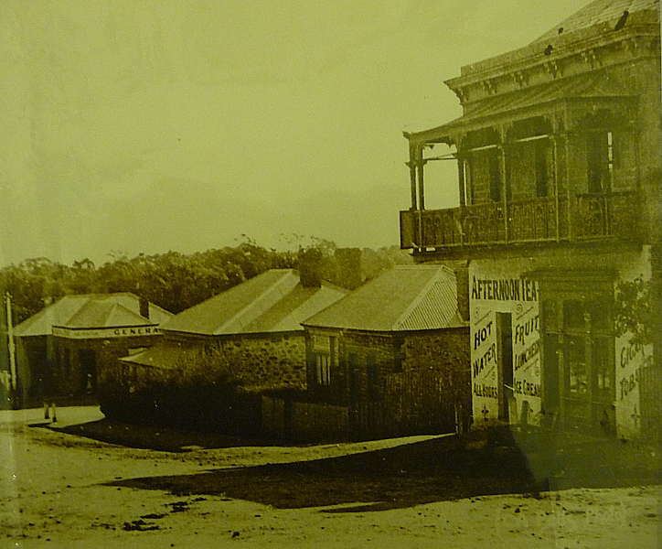

Volume 5 Number 3 June 2012

Title & Index page | 1 |  | Editorial, Disclaimer, Privacy Act. | 2
Message from Chairperson | 3 |  | Calendar, June to August | 4
Coromandel Valley Presentation Flier | 5 |  | Crimes of the Colony flier | 6
Haigh’s Chocolates flier | 7 |  | M. Prisk Tregoning | 8
Mitcham’s Vanished Occupations | 10 |  | FIRE! at Brownhill Creek | 11
Peter Waite & Queen’s Theatre | 12 |  | A passage to South Australia. | 14
The mystery of Sarah McHarg’s disappearance, 1841. | 15 |  | Animal Stories | 19
Ball Lightning, Steamer Engines | 20 |  | Important Notices for all! | 21
What are we celebrating? 1836-1936 | 22 |  | Address Page | 24

OFFICE BEARERS FOR 2012

Patron: | Mr Tim Oughton | Principal Scotch College
Chairperson | Julie Hogan | Tel: 0430472262 or 8338 3238
Vice Chairperson & Editor | Rick Irving | Tel: 08 8272 9707
Treasurer | Brian Angus
Secretary | Cheryl Schneider
Committee Members | Trish Cosh | Margaret White  K
 | John Wood | Christine Edwards
 | Rowena Atkinson
EDITORIAL
Recently, we heard Caroline Quentin, the presenter a British Television Program called Restoration Home, while telling us about the restoration of Calverton Manor, a historical building in Buckinghamshire, U. K., that we were right in the centre of where the history was. This I immediately challenged in my own mind, as it is my belief that history can be found literally all around us. Wherever we are, there is some history just waiting to be discovered. It does not have to be of immense importance, but that does not matter. History, what ever it is about, is still history.

If we take this idea of history being all around us to its fullest extent, there ought to be enough historical information to fill many large volumes, let alone to fill this newsletter. So, what is history? History, one source tells us, is the branch of knowledge dealing with past events. So what is the definition of an event? An event, this same source tells us, is something that happens or is regarded as happening. They also point out that it can be an occurrence, especially one of some importance. So, history is to do with things that happened in the past.
DISCLAIMER
Views and opinions expressed in articles in the Newsletter do not necessarily reflect the views of the Mitcham Historical Society Inc. While every effort is made to ensure the accuracy of articles printed, responsibility is not accepted for any errors they may contain that are out of the Society’s control.
THE PRIVACY ACT
A member’s personal information collected by the Society, for example name, address and telephone number, will only be used for forwarding of the Newsletter and relevant information concerning the Society. The information will not be shared, sold or given to any third party without the member’s consent. Any e-mails will be treated as above. However, any information sent by e-mail will be at the sender’s risk and the Society will not be held responsible for any unintended use or disclosure of this.

MESSAGE FROM CHAIRPERSON
Hello to all and as usual months have passed quickly with winter now upon us. The trees have given up their multi-coloured foliage and a bleaker vista is now the norm. The MHS has progressed nicely with a few successful functions undertaken. I would like to thank both our members and committee persons who provided great assistance to make our recent events a success and to our loyal members and associates who attended. A special mention is made to John Wood and Peter Basedow who without their tireless efforts the Mines, Wines & Market (Battunga) Bus Trip in April would not have taken place. Glen Woodward shared his extensive knowledge of the Mitcham Village area when he undertook the Twilight Walk in March. For the About Time State History Month activities in May we undertook the tour of historic Strathspey in Mercedes College and Allison’s Apothecary was opened to the public. I would like to thank Trish Cosh who kindly opened the heritage property, spending many hours giving up her time for the public viewings. Unfortunately on a sad note, Maggy Ragless the Community Historian for the Mitcham Heritage Research Centre, passed away suddenly recently. She was devoted to the preservation of history and will be sadly missed. We offer our sincere condolences to her family and friends. I would like to note that the MHS has been proactive in a mission to prevent the proposed dam being constructed in the local heritage Brownhill Recreation Park. The proposed dam will not only endanger existing heritage sites but will affect the natural flora and fauna that only exist in this delicate location. As we have a vested interest in the outcome we have given a donation to the No Dam Action Group. The voice behind this group, Ron Bellchambers has kindly agreed to speak at our AGM in September. Anyone who may wish to have further information concerning the dam proposal and its impact on the area can contact Ron via email: rde.bell@bigpond.net.au or by post to the Brownhill Creek Association, PO Box 113 Mitcham Shopping Centre SA 5062. In conclusion I would like to wish everyone well and remember –
“The history that we have all around us exists only from the protection and preservation by others before us”



PROGRAM FOR 2012, June to August

JUNE (Wednesday 13th)
Coromandel Valley & Districts National Trust Presentation
Speaker: Hugh Magarey
Time: 7.30pm
Drawing Room, Scotch College
Contact: Julie Hogan: 8338 3238 or 0430 472 262

JULY (Tuesday 17th)
“Crimes of Adelaide” – State Library Tour
Tour: 11am – 12am
(Meet at the State Library, North Terrace 10.45am)
Contact: Julie Hogan: 8338 3238 or 0430 472 262

AUGUST (WEDNESDAY 22 ND) AT 11.20
HAIGH’S CHOCOLATE TOUR
BOOKINGS ESSENTIAL - SEE FLIER
ON PAGE 7 FOR DETAILS
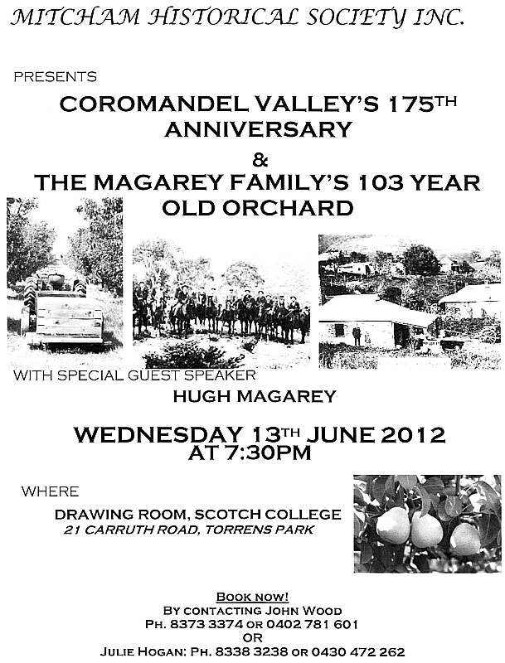
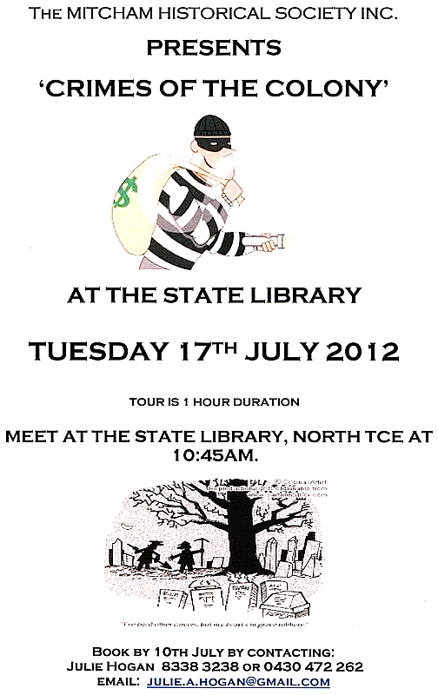
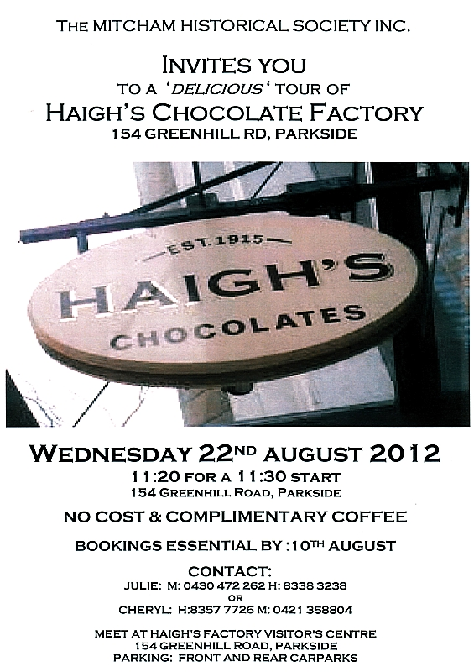
A Chemist by the name of Methuselah Prisk Tregoning.

It was announced in The Advertiser for the 17th of September 1904, that Methuselah Prisk Tregoning had, in accordance with the provisions of the Pharmacy Act, gained a full pass after an examination on September the 6th.

Tregoning, born at Moonta in 1878, was a chemist, optician and amateur photographer at Gawler Street Mount Barker. M. Prisk Tregoning (as he named himself) took up residence in Mount Barker early in 1905, when he was the secretary & treasurer of the Mount Barker Athletic Club. While he was not actually listed as a chemist that in that report, he is listed as “M. Prisk Tregoning, Secretary. Address – Chemist. Mount Barker” in October of that year. He was the secretary of the Mount Barker Athletic Club. He was also the General Secretary of the Mount Barker Literary and Musical Competition Society.

On page 9 of The Register for the 9th of April 1909, it stated that “Regret is expressed on all sides at the impending removal of Mr M. P. Tregoning, who during his four years' residence has been a most active business man.” Later that year, after visiting Sydney, he and his wife moved to Henley beach, where during 1911 he gave first aid to a child who had almost drowned, who after two hours' treatment she was taken to her home. He is noted in the article as a chemist.

It was reported page 8 of The Advertiser for Friday 21st of February 1913, that “Mr. M. Prisk Tregoning, of Henley Beach, who underwent a serious operation at Ru Rua Hospital late Tuesday week, is making rapid progress towards recovery.”

In January 1914, before announcing the opening of his Lower Mitcham shop, Tregoning advertised for a “Chemist’s apprentice for modern pharmacy at Mitcham.” He was living in Payneham at the time. The later advertisement heralding the opening of the Lower Mitcham shop was rather interesting:-

M. PRISK TREGONING, CHEMIST
(Late of Henley Beach and Mount Barker), will open 'THE MITCHAM PHARMACY at the Corner of Unley and Angas Roads, LOWER MITCHAM (Unley & Mitcham cars stop at door),

ON WEDNESDAY MARCH 11th

The Pharmacy is well appointed and furnished with all the Best Products of modern Pharmaceutical Art

TREGONING’S WELL KNOWN PROPRIETARIES OBTAINABLE.
POSTAL ADDRESS— LOWER M1TCHAM. PROMPT DISPATCH

It not only states where the shop was, but also mentions “well known proprietary lines”.

Earlier in this article, Tregoning’s operation at Ru Rua was mentioned, and it is possible that it was due to his illness that he passed away so early in his life. There is a Death Notice on page 14 of The Advertiser for Saturday the 23rd of December 1916, which states the following:-
“TREGONING.-On the 22nd December, M. Prisk Tregoning, chemist, Unley-road, Lower Mitcham, beloved husband of Helen Clifford Tregoning, aged 38 years.“
Vanished occupations of Mitcham.

What were some of the businesses carried out in Mitcham in the past, occupations that have now vanished? Three spring readily to mind, those of tanning, mining and coach building.

Two brothers, Daniel and Robert Ledgard had formed a partnership sometime prior to 1848, and operated a tanning business in Brownhill Creek. Notice of the dissolving of this partnership was published in the South Australian Register in July 1848.

The notice read “NOTICE is hereby given that the partnership lately existing between Daniel Ledgard and Robert Holdsworth Ledgard, carrying on business as tanners, at Mitcham, on Brownhill Creek, was dissolved by mutual consent on the 4th day of May, 1848. All debts due to and owing by the said partners will be received and paid by Daniel Ledgard.
DANIEL LEDGARD.
ROBERT HOLDSWORTH LEDGARD.
Witness— John Stephens.”

Robert and brother Daniel settled in Mitcham, buying lots 23, 24 and 25 in Mitcham Village, where the Edinburgh Hotel now stands.

John Grainger is remembered for many things in the city of Mitcham, but what about John Grainger, Mine Operator? We do not know for sure if he actually was a miner, but he certainly was the mine operator, as it was in his name and on his land. The following can be read on page 3 of the South Australian Register for Saturday 28 October 1848. “In our next Share List we shall have to introduce another new mine, now being worked at the Brownhill Creek, in the property of J. Grainger, jun., Esq. The operations are being conducted by a company denominated 'The Wheal Grainger Mining Company,' under lease for twenty-one years, at a dish of one-eleventh, and the undertaking is divided into 128 shares, on the cost-book principle, a plan usually adopted in Cornwall Three lodes have been discovered, of a character surpassing in promise any of the lead mines on this side the range of hills, on one of which a level has been driven upwards of twenty-five fathoms. A cross-course is now in progress to intersect the whole of the lodes. The ore is of a different kind to any which we have hitherto seen, containing bismuth, lead, and silver, and would be pronounced by mineralogists as bisthmatic silver ore. There are also some good stones of copper occasionally found in the lode. The opinion expressed by all the practical miners who have seen it is encouraging, and we think we shall shortly have the pleasure of congratulating the proprietors on possessing a highly productive mine. We learn that bismuth realises 2s per lb. in England.

T. J. M. Richards started coaches in Pulteney Street before 1886, as the partnership he had with J. W. Fisher “was dissolved by mutual consent” early in April in that year. Richards moved to West Mitcham, near the railway, soon after, and was still there in 1899, when he advertised for a first class body maker and a good jobbing hand. By 1914, his factory was in Hindmarsh Square.
FIRE!

We all know and appreciate Brownhill Creek. Being a grassy area, there have been fires there. One is described in the “Adelaide Morning Chronicle” for Thursday 6 January 1853, on page 2. It states: “FIRE.-A conflagration took place in the hills in the neighbourhood of Mitcham and Brownhill creek, on Tuesday last, which burned most furiously for some hours, but we have not heard with any damage to any private property. By dark the fire had very much decreased, but from the town had a very picturesque appearance, resembling an illumination very similar to the fires of the diggers at the Bendigo and Mount Alexander diggings.”
PETER WAITE

Peter Waite, born a Scot, had great faith in the future of Australian pastoralists. In amassing great wealth he had had no help, other than his own shrewdness and capacity for hard work, but he knew the great value of scientific research to the man on the land. When he died, he left an enormous sum (until then, one of the biggest benefactions made in Australia) to establish the Waite Agricultural Research Institute at Adelaide University. Here all sorts of subjects, including botany, entomology, horticulture and forestry, are studied by senior scientists, and the valuable findings they have made have enriched South Australia.

Peter Waite was born in Kircaldy, Fife-shire, Scotland, was apprenticed as a boy to an ironmonger, and spent nine years as a shop assistant. It is not hard to imagine how this rather limited kind of work must have irked the spirit of a young man so cut out to be a pioneer. At last, when he was 25, Waite set sail for Australia, following his brother, James, who had already settled in South Australia, and was doing well on a sheep station. At first, young Waite worked as his brother's jackeroo. Then the brother was drowned while trying to cross a flooded creek and Peter Waite took over the property.

Peter Waite was one of the first men in Australia to realise that it was an advantage to fence sheep in, rather than let them graze in flocks tended by shepherds. Only 11 years after he had been in Australia, he imported 265 tons of wire from England, and set about wiring his properties. Later, he was to spend many thousands of pounds on wire, and other pastoralists, seeing how well the system worked, followed his example. Today, of course, all Australian properties are wired, with the exception of some huge cattle runs.

Peter Waite also learned early in his career to appreciate the value of water. He suffered crippling losses in the great drought of 1866, but he managed to keep his breeding sheep alive and to rebuild his flocks. His slogan ever afterwards was "big dams, small paddocks" — a policy that has become a classic.

Peter Waite's strong character, his energy and resourcefulness attracted the attention of a leading grazier, Sir Thomas Elder Smith, who offered to go into partnership with him to develop a property in northern South Australia called Murtooroo (an aboriginal name meaning "food place"). Under Waite's brilliant direction, some of the finest sheep flocks in Australia were built up on Murtooroo, and it remains one of the country's show places. It was typical of Waite that he realised a new breed of sheep was necessary in the north, and by clever cross-breeding he produced just the right type of animal to stand up to the dry conditions of the area. When his active days as a pastoralist were over (he lived to the great age of 88), Waite went to live in Adelaide to look after his many commercial interests and to take an increasing interest in charity and in the University of Adelaide.

Although he was by then one of the richest men Australia had known, he remained modest and retiring, and was always reluctant to talk about his career. Despite his age, he kept on working until a few months before his death. It was unthinkable that a man of his driving spirit should ever retire.
THE QUEEN’S THEATRE

IN the “South Australian” for Tuesday 3 October 1848, on page 2, there is an interesting brief report about the Queen’s Theatre in Adelaide. It states “NEW QUEEN'S THEATRE.-We have much pleasure in announcing that his Excellency the Lieutenant-Governor and Lady Young, intend honouring Miss Lazar's concert, on Monday evening next, with their presence. We understand the arrangements will be upon a very extensive scale, and a full house may be expected to welcome the distinguished patron!” I wonder who Miss Lazar was? Mr. Lazar was the manager of the Queen’s Theatre at the time.

A passage to South Australia, a widow and
her children’s epic journey

This is a story about a widow from Glasgow, who with her twelve children, came to live in South Australia.

The thought of having twelve children conjures up challenges but the fact that this occurred over 170 years ago in the early days of colonization makes the story a little more interesting. This is the true story about my great-great–great-grandmother who came here in 1840 and settled near Woodside in the Adelaide Hills.

Due to the hard work of my relatives [Doug Hooper and Julie and Ben Evans] I am able to draw on the book they wrote [Weavers to Wapstraws] to take us through a journey that has resulted in an estimated 9000 descendants of Margaret Maxwell Kelly of Scotland.

Every family’s reasons for leaving their place of birth differed, and included political, religious and economic ones. In the case of the Kelly’s, the poor economic circumstances of Glasgow by 1837 were enough reason. The 1861 Census Return showed that in Glasgow 50 per cent of children died under the age of five years. Many worked in mines where the pit bottoms were like common sewers.

The sixteen week voyage was made in small ships in which space was at a premium. Each passenger had to provide a mattress and for a double that was to be 3 feet wide and 6 feet long. Many couples today sleep in a king size bed which is 6 feet wide. Fresh water was rationed and food salted.

Members of the family arrived on 18th June 1839 and landed at Port Adelaide. There was no wharf, and passengers had to alight on mud flats which after three days rain were in such poor condition that it was easy to see why Port Adelaide was known as Port Misery.

In a letter housed in the Mortlock Library, and written by one of Margaret's sons in September 1839, it was stated that there was much to like about Adelaide including the climate. Land about 4 miles from town could be purchased for about 5 pounds per acre. [Three of the older children migrated before Margaret and the other children.] Margaret was instructed to bring many items to Adelaide, including two milk churns, a cheese press and other items to run a small dairy. The list also included instructions on how to sell existing chairs because of their bulk and to purchase folding chairs in Glasgow and to bring them along with tables and carpets. The list even included wire covers for covering meat, washing tubs, lanterns, lamps wicks, a kitchen grate and a gun or two.

The mystery of Sarah McHarg’s disappearance.

The year is 1841. On the 3rd of June, young Sarah McHarg leaves Mr. Burr’s survey camp at the Meadows to walk to her father’s home in the Meadows, distant about two miles and a half, along a well-beaten track which she had often gone before . We know that Sarah’s father John McHarg purchased land there either in 1839 or 1840, as the Register informs us:-

John McHarg and his family arrived in 1839 from Clendrie parish of Inch, Wigtonshire, Scotland.

That he was able to purchase land is in a notice that appeared on page 3 of the South Australian Gazette and Colonial Register, on Saturday 23 March 1839.

SPECIAL SURVEY - AN excellent opportunity occurs for purchasing from 100 to 300 acres of Land in the beautiful special survey entitled the Meadows. Water frontage, fine meadow flats, and extensive back run of the finest description are included in this beautiful district. Apply to ROBERT COCK, or to GEORGE DEANE, North-terrace.

She fails to arrive.

Her “Mysterious Disappearance” is reported briefly on page 3 of the South Australian Register, for Saturday 19 June 1841. This is what was written:-

Mysterious Disappearance of a Female.—

For some days past, the police have been actively engaged in investigating into the circumstances connected with the suspicious disappearance of a young woman named Sarah McHarg, who left Mr. Burr's survey camp, in the Meadows, at half past one o'clock on Thursday, the 3rd instant, to proceed to her father's house, distant about two miles and a half, along a well-beaten track which she had often gone before; and notwithstanding the most minute enquires made by Sub-Inspector Lichfield (accompanied by one of Mr Burr's men) at every hut and station for miles round, not the slightest trace can be obtained of her. From information sent into Adelaide on Monday last by Mr. Lichfield, Inspector Stuart gave orders for the immediate apprehension of a man named Murray, a stock-keeper, who had come to town with cattle from the neighbourhood the day previous. The prisoner underwent a private examination before the Resident Magistrate, and remanded for a week. On Thursday morning, Sub-lnspector Lichfield, accompanied by Mr Burr, again started to make still farther enquiries, and narrowly search the country in the neighbourhood of the girl's father's house. She had on a green and white cotton gown, with a tippet trimmed with black velvet, a pink apron, and a straw bonnet with light ribbons. She has a deformity in one of her feet, and lived as servant for twelve months with Mrs Bouch, of Hindley street.
“A man named Murray, a stock-keeper, who had come to town with cattle from the neighbourhood the day” was assumed guilty of something and was apprehended by the police. He was “under suspicion” – but of what? On page 3, the Southern Australian for the 29th of June gives a very brief report of the proceedings.

MYSTERIOUS CIRCUMSTANCE.-We regret to find, that no clue has yet been obtained to the mysterious disappearance of Sarah M'Harg, from Mr. Burr's Survey camp, although Murray is still in custody under suspicion.

The trail goes cold. There are no more reports in newspapers for over two years. What has happened to young Sarah McHarg?

In September 1843, Sarah’s fate is revealed. The Southern Australian, on page 3 of Friday 8 September 1843, reminds us – “Many of our readers may remember that about two years ago a young woman, named Sarah M'Harg, was lost in the bush, and though a most active and persevering search was made, no trace of her could be found in any direction.”

The report stated that:-

MANY of our readers may remember that about two years ago a young woman, named Sarah M'Harg, was lost in the bush, and though a most active and persevering search was made, no trace of her could be found in any direction. When last seen, she was going from a survey camp to her father's house in the Meadows, a distance of four or five miles, by a beaten track, and it was generally supposed that she had been murdered. We have now to announce the fact, that her remains have been discovered, in a dense forest near Currency Creek, so that she must have lost her way, wandered about fifteen miles out of the proper track, and finally died of starvation. Previous to her death, she had built a sort of wurley of branches, round which her bones have been found, apparently torn asunder by wild dogs; her clothes were also found rotted, but easily recognised, and two books, little injured, which she was known to have with her. In one of them the following words have been traced, scratched with a pin:-" Dear Elizabeth (a sister of the deceased) grieve not for me, I am resigned to my fate." The unfortunate girl was a native of Clendrie, parish of Inch, Wigtownshire, in Scotland, and came to this colony, with her parents, about four years ago. We understand the Coroner has gone to hold an inquest on the remains.

Perhaps there is also another mystery also, that of when was “A man named Murray” released?

OUR COLONIAL ALES, 1844.

The Southern Australian, on Friday the 10th of May, 1844, included a good summation of the quality of South Australian Ales. It can be found on page 3, and is reproduced here:-

THE COLONIAL ALES.-It gives us great pleasure to learn that ales are now made in this colony of really excellent quality. W e have ourselves tasted the ales brewed by Messrs Colyer, Primrose, Crawford & Tinline, and Auld, which fully bear out the above report, and, doubtless, others are equally successful. From the samples we have tasted, we are fully convinced, not only hat at no distant period, importation in this article must be as completely stopped as that of corn; but, that a large export trade will be established. The progress that has been made during the past year, is as astonishing as it is satisfactory. The brewers are of course in high spirits, and are preparing to increase their business to the full extent of the demand which most of them are unable at present to meet. One or two brewers have made a capital article of porter, which, of course, shews what may be done. The springing up of the brewing business has been of great service to the farmers; and, if it was only for this reason, the parties engaged in it deserve all the encouragement which the publicans and the public hare given them.
Some Animal Stories

The Black Tiger

The black Tiger brought from Malacca in the Cacique, was purchased by Mr Creech, of the Union Inn, Weymouth-street. We paid the royal stranger a visit on Monday, and it certainly struck us as a curiosity - we do not remember to have seen one of the kind in any English collection. It is jet black, and very wild, not large, but evidently of immense muscular power. Its appetite is ravenous and savage, as an unfortunate cat, an involuntary intruder in its cage, very quickly experienced. The brute with a single stroke of its paw literally smashed its visiter, and greedily swallowed the blood; the carcase, however, of Grimalkin it rejected, perhaps on the score of relationship. We believe Mr Creech intends shipping his unique purchase to London or Sydney. In the former place it would no doubt realize a good price.

KITE-FLYING EXTRAORDINARY

A lad on board the Waterwitch last trip was amused by flying a kite from the stern. It rose to a considerable height, and the string caught a passing albatross by the wing. The struggling of the bird broke the cord beneath, but its hold above was firm, and the novel sight was presented to those on board of an albatross flying a kite. The bird held its course, and the toy floated high in air, till both were lost in the distance.

Ball Lightning

Around the 20th of November, 1846 some draymen carting copper ore had a very interesting experience. The South Australian for Friday the 20th of November describes it rather well.

SINGULAR PHENOMENON.- On Friday evening, about six o'clock, during a severe thunder storm at the Light, and while a number of draymen, with their drays, coming from the Burra Burra Mine, were encamped about a gum tree, a phenomenon of singular appearance occurred. One of the men, happening to look up, perceived a large fiery ball approaching slowly towards them, and called the attention of his companions to it. In a few seconds afterwards, it came in contact with the tree, and burst with a most terrific noise, shivering the main stem, and scattering the smaller branches over the drays. So great was the noise, that some of the people could not hear the others speak tor a short time afterwards.

Engines for the River Murray Steamer Bunyip

COLONIAL MANUFACTURES. — Mr. George Wyatt, of the Adelaide Foundry, North-terrace, has just turned out of hand, in the short space of three months, a pair of high-pressure oscillating marine engine, of 20 horse power each, for the Murray River steamer Bunyip, the property of the Messrs. Randell. The workmanship and general finish of these engines are highly creditable to the foundry, and it is a gratifying circumstance that such work can be produced in the colony. The boiler, which is to be made in Sydney, and which was ordered some time before the engines, has not arrived yet.

MITCHAM HISTORICAL SOCIETY INCORPORATED

NEW MEMBERS SINCE OUR PREVIOUS NEWSLETTER

We acknowledge and sincerely welcome Shelley Smithers, Ian & Chrissie Richardson and Sonya Svaagan-Jelic who have shown support to our Society by becoming members.

FRIENDLY REMINDER FOR MEMBERSHIP RENEWALS

Just a reminder that current 2011/12 memberships will now be up for annual renewal from June 30th. These can be paid either by cheque, bank deposit or internet.

Mitcham Historical Society Inc. Bank Details:
BSB: 105- 084 A/C No. 045933840

Membership Types:
Individual $25 Family $35 Pension Concession/Society $15 Corporate $100

NOTICE OF ANNUAL GENERAL MEETING
TUESDAY 25TH SEPTEMBER 2012
Time: 7.30pm Where: Drawing Room, Scotch College
Carruth Road, Torrens Park

Guest Speaker: Mr Ron Bellchambers
Spokesperson for N0 DAM IN BROWNHILL CREEK ACTION GROUP

AGM formalities will follow the Guest Speaker Presentation
Don’t’ Stress! Present Committee Members will continue on,
(So you need only nominate for a Committee position if you wish to.)
Please come along and enjoy our hospitality with wine and cheese refreshments available.
WHAT WE ARE CELEBRATING
By the Hon. R. Layton Butler, M.P., Premier of South Australia.

ANNIVERSARIES are always occasions for retrospection, and it is therefore fitting at this time, when we are approaching the climax of our Centenary celebrations, to cast our minds back to the establishment of our State, and to recall the events we are celebrating in our Centenary year.

It will be just 100 years on December 28 since a little band of settlers, but newly arrived from England, gathered near a curiously old, bent gumtree at Holdfast Bay to hear read the Proclamation which established South Australia as a free province under the British Crown. This year at Glenelg on Commemoration Day we will have the privilege of seeing that historic ceremony re-enacted, and of doing honour to those sturdy pioneers who bestowed upon South Australia those special characteristics which have throughout its history distinguished it from the other Australian States.

In the hundred years that have passed since those first settlers reached South Australia, our State has passed successfully through many vicissitudes and has experienced many triumphs, until to-day, when it is commemorating the Centenary of its foundation, it has a history of which it has every reason to feel proud. In many respects South Australia and Adelaide have shown the way, not only to the other States of Australia, but also to the rest of the world. Adelaide is the oldest municipality and the third largest city in Australia. It was first incorporated in 1840, four years after the State was founded. The system of voting by ballot by putting a cross opposite the name of the selected candidate originated in South Australia. This State constructed the first State-owned steam railway in the world—that between Adelaide and Port Adelaide. The South Australian Real Property Act, 1858 (commonly known as the Torrens Title Act), which simplified very considerably the system of land transfer, has been adopted by all the other Australian States, and by practically every civilised nation in the world.

It was a South Australian explorer, John McDouall Stuart, who blazed the trail across the continent between Adelaide and Darwin in 1862, along which the Overland Telegraph Line was laid ten years later, thus putting South Australia for the first time in direct cable communication with the rest of the civilised world. Likewise, it was two South Australians, Sir Ross and Sir Keith Smith, who pioneered the airway between Britian and Australia, along which aeroplanes carrying passengers and mails are now flying twice weekly.

South Australian farmers have long been recognised as among the most up-to-date and progressive in Australia, and they have been responsible for many farming reforms and for the invention of implements which have revolutionised agricultural practices in Australia. The Ridley reaping machine (first used in 1843), which greatly reduced the cost of harvesting and made the growing of wheat on marginal lands possible, and the stump-jump plough, which made practicable the cultivation of mallee lands without the necessity of first grubbing out the stumps of the trees, are but two cases in point. This latter invention, combined with the method of rolling down and burning-off scrub, has made possible the utilisation for wheat-growing of thousands of acres of mallee country in New South Wales, Victoria, Western Australia, and South Australia, which would otherwise be absolutely useless. South Australia produces four-fifths of the wine and 96 per cent. of the brandy made in the Commonwealth, and manufactures ten times as much wine as the next largest producer. South Australia also manufactures approximately four-fifths of the motor bodies produced in the Commonwealth, and not only supplies the requirements of most of the other States, but also exports bodies to India, the Netherlands East Indies, and Malaya.

This is a record of which any State might well be proud, and which we are commemorating in our Centenary celebrations. The keynote of those celebrations is pride and thankfulness — thankfulness for the splendid heritage that has been bequeathed to us, and pride in our sturdy forefathers who established our State upon such firm and enduring foundations.
CORPORATE MEMBER LOGOS

It is with pleasure that we present here the Business Logos of our
Corporate Members, namely:
The Edinburgh Hotel & Cellars Adelaide Expo Hire
Scotch College Mitcham Antique Gallery
Dowling City Country Mitcham Square Newsagency








----
POSTAGE
PAID
AUSTRALIA
PRINT
POST
PP 536729/00025
If undeliverable return to:
Mitcham Historical Society Inc.
PO Box 903 Mitcham Shopping Centre
S. A. 5062
Mitcham Memories
Print Post Approved
PP 123456/12234

Address Label

http://www.artgallery.sa.gov.au/noye/Photogs/A_small.htm
The Advertiser, Wednesday 4 January 1905, page 9
The Advertiser, Saturday 13 October 1906, page 2
The Advertiser, Saturday 15 February 1908, page 2
The Register, Friday 9 April 1909, page 9
The Register, Monday 19 April 1909, page 3
The Advertiser, Friday 6 January 1911, page 8
The Advertiser, Monday 19 January 1914, page 11
? The Register, Tuesday 10 March 1914, page 2
South Australian Register, Wednesday 19 July 1848, page 1
Containing bismuth.
The South Australian Advertiser, Monday 12 April 1886, page 2
The Advertiser (Adelaide, SA : 1889 - 1931), Monday 9 October 1899, page 8
The Advertiser (Adelaide, SA : 1889 - 1931), Friday 7 August 1914, page 11
? From Famous Australians Book 2 Commonwealth Saving Bank, 1960, page 19.
? South Australian, Tuesday 22 February 1848, page 2
? South Australian Register, Saturday 19 June 1841, page 3
? The Register, Friday 10 February 1928, page 14
? South Australian Register, Saturday 19 June 1841, page 3
? Southern Australian, Tuesday 29 June 1841, page 3
? Southern Australian, Friday 8 September 1843, page 3
? Southern Australian, Friday 8 September 1843, page 3
? South Australian, Friday 25 May 1849, page 2
South Australian Register, Saturday 19 September 1857, page 2

